 |  | Bosham Primary School Learning Experiences
 |  | Autumn |  |  |  |  |  |  |  |  |  |  |  | Spring |  |  |  |  |  |  |  |  |  | Summer
 |  | Autumn 1 (7 weeks) |  |  |  |  | Autumn 2 (7 weeks) |  |  |  |  |  |  | Spring 1 (6 weeks) |  |  |  |  |  | Spring 2 (6 weeks) |  |  |  | Summer 1 (6 weeks) |  |  |  |  |  | Summer 2 (7 weeks)
Big Question |  | Do the choices we make matter to others? |  |  |  |  |  |  |  |  |  |  |  | How can we be the change that we want to see in the world? |  |  |  |  |  |  |  |  |  | How does life on earth thrive?
Oppys (YR)  Learning Experiences |  | Special You |  |  |  |  | Season to Season |  |  |  |  |  |  | What are Other Places Like? |  |  |  |  |  | Beyond the Sky |  |  |  | What is Africa Like? |  |  |  |  |  | How Wonderful is our World?
 |  | 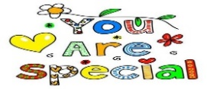 |  |  |  |  | 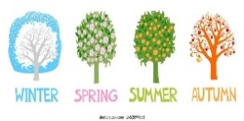 |  |  |  |  |  |  | 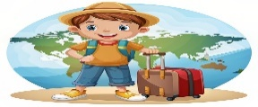 |  |  |  |  |  |  |  |  |  | 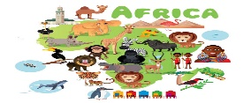 |  |  |  |  |  | 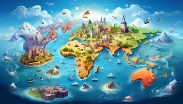
Big Question |  | Do the choices we make matter to others? |  |  |  |  |  |  |  |  |  |  |  | How can we be the change that we want to see in the world? |  |  |  |  |  |  |  |  |  | How does life on earth thrive?
Toppers (Y1)  Learning Experiences |  | In The Wild Wood  Geography & RE (Judaism) |  |  | Toppers & the Porridge Thief  Art |  | Remember, Remember  History | Rats Toys & Kings  History |  |  |  |  | KS1 Nativity | Wonderful Me  Science |  |  | Danger at Sea!  Geography & History |  |  |  | focus | New Spring, New Life  Science & RE (Christianity) |  | Powerful Plants  Science |  |  |  | The Carnival of the Animals  Science |  |  | Phonics |  |  | Around the world  Geography |  | Day
 |  | 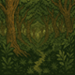 |  |  |  |  | 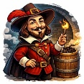 | 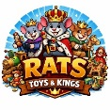 |  |  |  |  | KS1 Nativity | 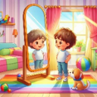 |  |  | 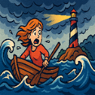 |  |  |  | focus | 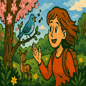 |  | 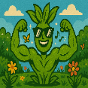 |  |  |  | 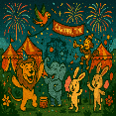 |  |  |  |  |  | 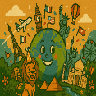 |  | Day
Big Question |  | Are we all the Same? |  |  |  |  |  |  |  |  |  |  |  | Can one person make a change? |  |  |  |  |  |  |  |  |  | Do we all have the same values?
 |  | Deep into the Woods  Science |  | Jesus as Saviour  RE (Christianity) |  | Experience | Incredible You  Science | Where in the World?  Geography |  |  |  |  | KS1 Nativity | I Spy with my London Eye  History & Science |  | How Do Christians Pray  RE (Christianity) |  |  |  |  | school | Man on the Moon  History |  | Wild & Wonderful  Geography & Science) |  |  | The Secret Garden  Science |  |  |  |  |  | How do Muslims show compassion RE (Islam) |  |  | Sports
Fevas (Y2)  Learning Experiences |  | 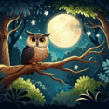 |  | 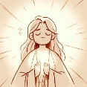 |  | Experience | 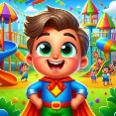 | 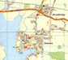 |  |  |  |  | KS1 Nativity | 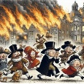 |  |  |  |  |  |  | school | 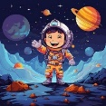 |  | 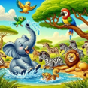 |  |  | 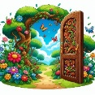 |  |  |  |  |  | 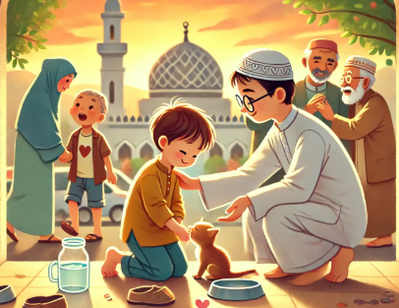 |  |  | Sports
Big Question |  | Does adversity make us stronger? |  |  |  |  |  |  |  |  |  |  |  | What makes our world special? |  |  |  |  |  |  |  |  |  | Survive or Thrive?
Lasers (Y3)  Learning Experiences |  | Submit & Obey!  RE (Islam) |  | Rock of Ages  History |  | Learning | Bones & Other Bits  Science |  |  | Shadowy Showpiece Extraordinaire  Science |  |  |  | Extreme Earth Science | Where my wellies take me Geography |  |  |  | Magnificent Magnets  Science |  | whole | Be Bold Be Strong  RE (Christianity) |  | Groovy Greeks  History |  |  |  | I Can Grow  Science |  |  |  | The Earth’s Kingdom  RE (Christianity) |  |  |  | includes
 |  |  |  | 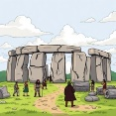 |  | Learning | 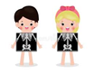 |  |  | 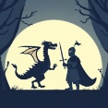 |  |  |  | 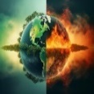 | 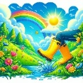 |  |  |  |  |  | whole | 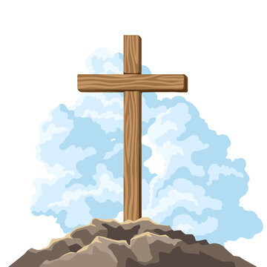 |  | 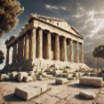 |  |  |  | 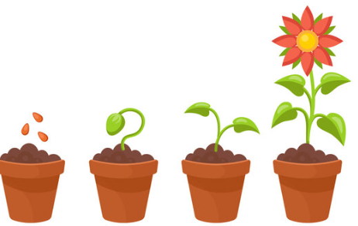 |  |  |  |  |  |  |  | includes
Big Question |  | Do all duties have to be fulfilled? |  |  |  |  |  |  |  |  |  |  |  | Are humans working against nature? |  |  |  |  |  |  |  |  |  | What makes a successful community?
Wayfarers  (Y4)  Learning Experiences |  | Ruthless Romans  History |  |  |  | School | Duty Dharma & Diwali  RE (Buddhism) |  |  |  | Rescue Mission  RE (Christianity) |  |  | Polluted Planet  Science & Geography |  |  | Chew, Poo & You  Science |  |  |  | with a | Powerful Problems  Science |  | The Great Commission  RE (Christianity) | What a Wonderful World Geography |  |  |  | The Mysteries of the Maya History |  |  |  |  |  | Sound  Science | which
 |  | 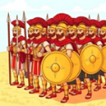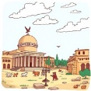 |  |  |  | School | 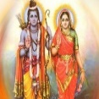 |  |  |  | 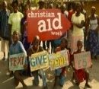 |  |  | 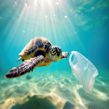 |  |  | 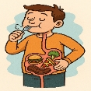 |  |  |  | with a | 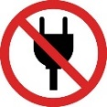 |  |  | 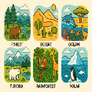 |  |  |  | 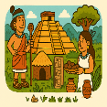 |  |  |  |  |  | 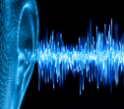 | which
Big Question | Where does true power come from? |  |  |  |  |  |  |  |  |  |  |  |  | What makes something truly human? |  |  |  |  |  |  |  |  |  | Could every journey lead to discovery?
Sunbeams (Y5)  Learning Experiences | Incredible Inventors  Science |  | Pathways  RE (Hinduism) |  |  | Whole | Fantastic Beasts  Science |  | Eucharist  RE (Christianity) |  |  |  |  | Amazing Egyptians  Geography & History |  |  | Heart’s Highway  Science |  |  |  | Week | Humanism  RE (Humanism) |  | Raiders or Traders  Geography & History |  | Pilgrimage  RE (Pilgrims) |  |  |  | The New World Geography |  |  |  |  | Are We Alone? History & Science | Week
Sunbeams (Y5)  Learning Experiences | 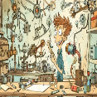 |  | 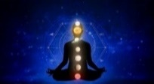 |  |  | Whole | 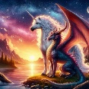 |  | 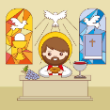 |  |  |  |  | 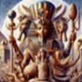 |  |  |  |  |  |  | Week | 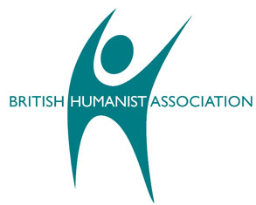 |  | 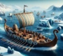 |  | 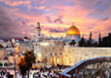 |  |  |  | 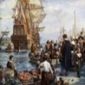 |  |  |  |  | 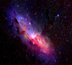 | Week
Big Question | What good comes from conflict? |  |  |  |  |  |  |  |  |  |  |  |  | Is there a limit to nature? |  |  |  |  |  |  |  |  |  | How do you want to be remembered?
Catamarans (Y6)  Learning Experiences | Fight or Flight  Geography & History |  |  |  |  |  | Fight or Flight  Science |  |  |  |  | Incarnation  RE (Christianity) |  | Reaching the roof  of the world  Geography |  |  |  | Darwin’s Discoveries  Science |  |  | Science | Resurrection  RE (Christianity) | KS2 SATs | Path to Enlightenment  RE (Buddhism) |  |  | Trails & Treasure!  Geography, History & Science |  |  |  |  |  | Bosham School Production |  |  | Sports
Catamarans (Y6)  Learning Experiences | 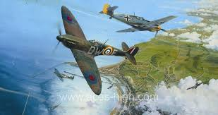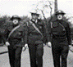 |  |  |  |  |  | 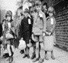 |  |  |  |  | 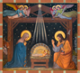 |  | 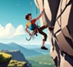 |  |  |  | 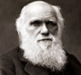 |  |  | Science | 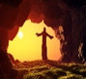 | KS2 SATs | 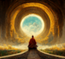 |  |  | 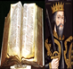 |  |  |  |  |  |  |  |  | Sports

