 | 
 | Bosham Primary School Learning Experiences for Y2 (Fevas)
 | Autumn
Big Question | Autumn 1 (7 weeks) |  |  |  |  |  |  |  |  |  | Autumn 2 (7 weeks)
Big Question | Are we all the Same?
Learning  Experiences | 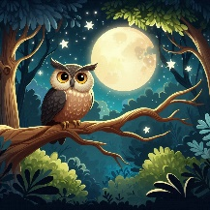 | Deep into the Woods  Science |  | 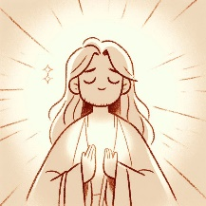 |  | Why was Jesus given the name Saviour? RE (Christianity) |  |  |  | 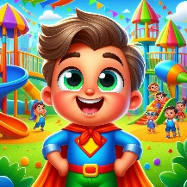 |  | Incredible You  Science |  |  | 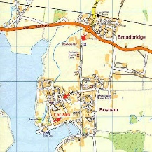 |  | Where in the World?  Geography
Key Learning | Science  - Explain the life cycle of a hedgehog.  - Compare the life cycle of a human to the life cycle of a hedgehog and understand that offspring grow into adults. |  |  | RE (Christianity)  - Understand what it means to rescue or save somebody.  - To understand that Christians believe God sent his son to save people.  - To understand that Christians believe why Jesus was given the name saviour. |  |  |  |  |  | Science  - Explain why it is important to exercise, eat healthy foods, drink water and be hygienic.  - Know why eating the right amounts of different types of food is important  Whole School Learning Experience |  |  |  |  | Geography  - Explain the difference between human and physical features?  - Compare human and physical features in Bosham to that in a village in Kenya  - Be able to draw a simple map and explain how a key works  - Describe human and physical features using key vocabulary  Nativity Production  Nativity Production
Big Picture | Pupils will learn about a variety of nocturnal animals and how they survive. They will make a shelter for a hedgehog using what they have learnt to choose the correct materials. |  |  | To begin our learning, we will explore Advent — the special time when Christians wait and prepare for the coming of Jesus at Christmas. We will discuss what Advent means and why people look forward to Christmas, thinking about hope and joy as we count down the weeks. During this time, everyone will have the chance to create and paint a clay angel as a symbol of the angels who brought God’s messages in the Christmas story. |  |  |  |  |  | We will learn about ourselves by making a family tree, writing facts about who we are, and drawing a self-portrait while finding out what all animals, including humans, need to live. Then we will explore how to stay healthy by learning about food groups, designing a balanced meal, and making a healthy snack together. Finally, we will write clear instructions for someone else to make a healthy sandwich. |  |  |  |  | We will write about our local area in Bosham by telling the story of our walk and drawing a map with a key so we can show where things are. Then we will learn about Africa by telling a story from there, making a leaflet to compare Bosham with a village in Kenya, and creating colourful art inspired by a Kenyan artist called Martin Bulinya whose paintings show people and patterns from African life. Finally, we will find out where we are in the world by labelling a big world map with the different continents and oceans.
Hook | Adopt an Owl |  |  | Share the story of the Nativity. |  |  |  |  |  | Come and join the circus! Challenge yourself to learn a new skill. . . |  |  |  |  | You will become explorers, making discoveries about the physical and human geography of the village!
Steps | Step 1 - Learn about Owls  - Sequence and retell the story of Owl Babies.  - Write a fact file for an owl.  - Create an owl picture in the style of Sandra Silberzweig  Step 2 - Learn about other nocturnal animals  - Visit from hedgehog rescue.  - Life Cycle of a hedgehog booklet (Science)  - Fact file for a woodland nocturnal animal.  - Design and make an animal home, having experimented with a variety of materials (Science/DT).  - Retell the story Foxly’s Feast (verbal) |  |  | Step 1 – Waiting for the Saviour through advent  - What is advent? What are we waiting for?  - Create and paint a clay angel  Step 2 -To learn the story of the first Christmas  - To use drama to learn the Nativity story.  - Sequence pictures of the Nativity.  Step 3 - Retell (write) the story of the nativity in our own words  - All to plan and write the story.  - Adapt -LA to write against pictures one sentence per picture |  |  |  |  |  | Step 1 – Let’s Learn About Ourselves  • Create our family tree  • Discover what is incredible about us.  • Write a fact file about ourselves  • Use lines and dots to create a self-portrait.  • Find out what animals (including humans) need to survive.  Step 2 - How do we stay healthy?  • Research different food groups and design a meal.  • Make a healthy snack  • Write instructions to make a healthy sandwich. |  |  |  |  | Step 1 - What is our local area like?  - To write a recount of our walk around Bosham.  - Draw a simple map of our local area and use a key.  Step 2 - What is Africa like?  - To retell the story of The Greedy Zebra.  - To write a leaflet comparing Bosham with a village in Kenya.  - To create a picture in the style of Martin Bulinya.  Step 3 - Where are we in the world?  - Label a world map with continents and oceans
Authentic Outcome | Pupils to design and make an animal home using the knowledge they have gained. |  |  | Perform Nativity to parents |  |  |  |  |  | Design and make a healthy snack. |  |  |  |  | To perform a production of ‘Children around the World’.
Key Vocabulary | adult  animal  baby  grow  human  life cycle  offspring  old  young |  |  | believe  Joshua  rescue  salvation  save  saving  saviour |  |  |  |  |  | child  exercise  food  healthy  hygiene  teenager  water |  |  |  |  | Human:  shop  farm  house  office  port  harbour |  |  | Physical:  beach  cliff  coast  forest  hill mountain  sea ocean river  soil  valley  season  weather
Spring
Big Question | Spring 1 (6 weeks) |  |  |  |  |  |  |  |  |  | Spring 2 (6 weeks)
Big Question | How can we be the change that we want to see in the world?
Learning  Experiences | 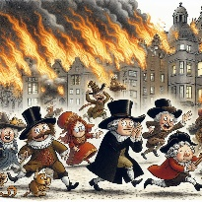 | I Spy with my London Eye  History & Science |  |  |  |  |  | How Do Christians Pray  RE (Christianity) |  |  |  |  |  | 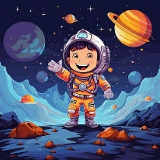 |  | Man on the Moon  History`
Key Learning | History  - Explain why different materials are suitable for different things because of their properties  - Answer questions about significant events during the Great Fire of London  - Explain why it started and how it stopped.  - Explain impact of the GFoL and how it changed London  - Identify key individuals during GFoL and their impact: Samuel Pepys, King Charles II and Mayor Thomas Bludworth  Science  - Explain why different materials are suitable for different things because of their properties |  |  |  | RE (Christianity)  - Christians believe they can pray to God in different way.  - Christians pray to God as a form of worship and conversation. |  |  |  |  |  |  |  |  | History  - To learn about a significant person (Tim Peake) in our own locality.  Science Week  - To learn about and understand a significant global event (First Moon Landing) and its impact.  D & T  - To design a purposeful, functional and appealing space buggy following a plan.  - To explore and use the mechanisms of wheels and axels.
Big Picture | We will learn about London today by finding the countries and capitals in the UK and writing an informative leaflet about the city. Then we will find out about the Great Fire of London by discovering what happened, writing a diary as if we were there, and making a Tudor house. Finally we will learn why the fire spread so quickly by looking at different materials, having a visit from the Fire Service, acting out the fire and writing a report, and then share everything we’ve learned with our grown-ups in our living museum! |  |  |  | To be added Spring 2026 |  |  |  |  |  |  |  |  | We will learn about the Solar System by discovering planets and writing a fact file all about it with headings and cool punctuation. Then we will design, build and test a Space Buggy to see how we can make it move. Next we will write about Bob from Man on the Moon and retell Toys in Space in our own words, and finally we will find out about astronaut Tim Peake and compare him to Neil Armstrong who was the first person to walk on the moon — learning how people go into space and what they have done.
Hook | We will become detectives by exploring artefacts to find out about the past. |  |  |  | To be added Spring 2026 |  |  |  |  |  |  |  |  | ‘Welcome to space’ – glo-sticks and virtual solar system to explore in a darkened room!
Steps | Step 1: What is London like today?  - Plot the countries & capitals of the UK  - Write an informative leaflet about London today (headings, sentence types, new punctuation)  Step 2: What was the Great Fire of London?  - Find out about the Great Fire of London  - Write a diary about the fire (first person, tense, editing)  - Design and make a Tudor house  Step 3: Why did the Great Fire of London spread so quickly?  Learn about materials and why they are good for different things  - Visit from the Fire Service  - Interpret the fire through music  - Re-enact the fire  - Write a chronological report (headings, paragraphs, tense, editing)  - To present our findings to our grown-ups in our ‘living museum’! |  |  |  | To be added Spring 2026 |  |  |  |  |  |  |  |  | Step 1: What is the Solar System?  - To learn about the Solar System.  - Write a fact-file about the Solar System (introduction, headings, possessive apostrophes (singular).  Step 2: How can we make a Space Buggy and make it move?  - Design, make and evaluate a Space Buggy.  Step 3: How can we describe Bob in the story ‘Man on the Moon’?  - Write a character description of Bob (expanded noun sentences, commas, apostrophes, conjunctions)  Step 4: Can we sequence and retell in our own words Minnie Grey’s ‘Toys in Space’?  - To re-write ‘Toys in Space’ (different sentence types, new punctuation, subordinating conjunctions, editing).  Step 5: Who is Tim Peake/compare to significance of first moon landing (Neil Armstrong)?  - To research Tim Peake, using a variety of media and to create a fact-file about his life and achievements.
Authentic Outcome | Present our findings to our grown-ups in our ‘living museum’! |  |  |  | To be added Spring 2026 |  |  |  |  |  |  |  |  | Create a fact-file about Tim Peake and all of his achievements.
Key Vocabulary | durable  hard  heavy  light  strong  tough  water proof  weak |  | event  London  Pudding Lane  River Thames  timeline |  | Christian  difference  God  pray  same |  |  |  |  |  |  |  |  | famous  impact  Moon landing  Neil Armstrong  planet  solar system  space  Tim Peake
Summer
Big Question | Summer 1 (6 weeks) |  |  |  |  |  |  |  |  |  | Summer 2 (7 weeks)
Big Question | How does life on earth thrive?
Learning  Experiences | 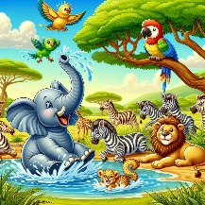 | Wild & Wonderful  Geography & Science |  |  | 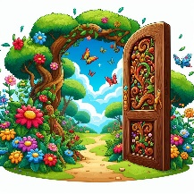 |  | The Secret Garden  Science |  |  |  |  |  |  | 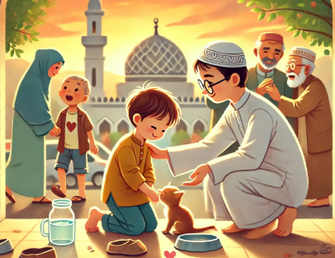 |  | How do Muslims show Compassion?  RE (Islam)
Key Learning | Science  - Know the difference between things that are living, dead, and things that have never been alive.  - Name a variety of plants and animals in their habitats, including microhabitats.  - Create and understand a simple food chain |  |  |  | Science  - Explore and describe what plants need to stay healthy.  - Observe and describe how seeds and bulbs grow into mature plants.  - Select and use a range of tools to cut, shape, join and finish the fairy houses,  - Select and use a range of materials according to their plan.    TAPs Assessment  - Describe what they have found out and use their results to make comparisons: children to order large pictures of their beans, label the key vocabulary and present it to others in their Science 3s. |  |  |  |  |  |  |  |  | RE (Islam)  - That Muhammad showed care that he cared for animals and people.  - That Allah is compassionate and merciful.
Big Picture | We will write a diary like Jamina from The Hunter, pretending to be her and telling how she found and helped a baby elephant in the African bush. Then we will make a clay penguin, learn cool facts about polar bears and retell the story of Solo in our own words. Finally we will find out about the famous artist David Hockney and try to paint colourful pictures inspired by his art. |  |  |  | We’ve looked UP in our Space Learning Experience; now it’s time to look DOWN at the ground! What DO plants need to grow? |  |  |  |  |  |  |  |  | To be added Summer 2026
Hook | What am I? Find the hidden clues and pieces of a jigsaw puzzle to guess what animal you are learning about first! |  |  |  | Year 2 come in to find a broken fairy house surrounded by a garden of wilted plants. A tiny letter next to it asks the class to find out how to keep plants alive so they can recreate their homes and gardens. The fairies’ poetry book of nature has also been damaged: can Year 2 help? |  |  |  |  |  |  |  |  | To be added Summer 2026
Steps | Step 1: To write a diary entry from the perspective of Jamina in ‘The Hunter’  - Write a diary entry about elephants from Jamina’s point-of-view  (first person, tense, expanded noun phrases, editing)  Step 2: To make a penguin out of clay  - To design, make, paint and evaluate a clay penguin.  Step 3: To write a non-chronological report about polar bears  - Where are the world’s hottest and coldest places?  - What facts do I know about polar bears?  - Write a voice-over in the style of Attenborough for a video about polar bears emerging from hibernation in the Arctic.  - Write a non-chronological report about polar bears (headings, paragraphs, questions, editing)  Step 4: To retell the story of Paul Geraghty’s ‘Solo’  - Re-write Paul Geraghty’s ‘Solo’ (different sentence types, new punctuation, subordinating conjunctions, editing).  Step 5: To paint in the style of David Hockney  - To learn about David Hockney. |  |  |  | Step 1: How do plants grow?  - To learn about what plants need to grow.  - Plant a bean and write a diary of its growth.  - Learn what is inside a seed, the lifecycle of a plant and what they need to stay healthy.  Step 2: What is a poem?  - Read different poetry to learn about features used in in poetry (alliteration, repetition, similes, onomatopoeia).  - Craft class poem: Explore different trees outside and, inspired by these, use poetry techniques and creative language to write lines of poetry about trees.  - Write own poem about trees using the five senses.  - Edit, improve and perform poems.  Step 3: Who was Claude Monet and how did he paint?  - Learn about Claude Monet and impressionism.  - Re-create Monet’s ‘Water Lilies’ using watercolour techniques.  Step 4: Can we design and make a fairy house?  - Make a fairy house using DT techniques and create fairy gardens by planting seeds and tending gardens.  - Evaluate houses and gardens against designs. |  |  |  |  |  |  |  |  | To be added Summer 2026
Authentic Outcome | Authentic Outcome = To learn to draw and paint in Hockney’s style, focusing on landscapes. |  |  |  | Make a fairy house and garden. |  |  |  |  |  |  |  |  | To be added Summer 2026
Key Vocabulary | alive  food chain  habitats  living  microhabitats |  | disciple  faith  trust  Zacchaeus |  | accurate  baby plant  food store  fruit  observe  oxygen  protect  record  seed coat  shell  shoot |  |  |  |  |  |  |  |  | Allah  compassion  mercy  Muhammad  Muslim

