
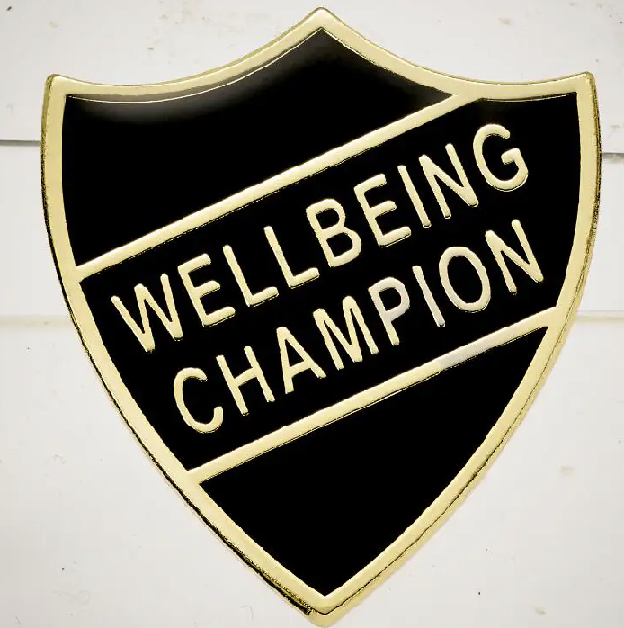
Well Being Champion Application Form

Do you want to be a Well Being Champion?

Roles & responsibilities
- Be a positive role model for younger children at lunchtime.
- Show good table manners and encourage others to eat politely in the hall.
- Help younger pupils if they are unsure about routines at lunchtime.
- Support children in joining in with games so everyone feels included.
- Encourage children to play safely and resolve small disagreements calmly.
- Listen to younger pupils if they are upset and help them find support from an adult if needed.
- Show our school values of respect, kindness, and responsibility at all times.
- Represent the school by making lunchtimes happy and safe for everyone.

Please be ready to share why you should be chosen with your class and teacher next week. There is space below to make notes to help you present why you should be a Well Being Champion this year. Good luck

Name: Class:

The Well Being Champions will be announced in our Celebration assembly on the Thursday 2nd October.

