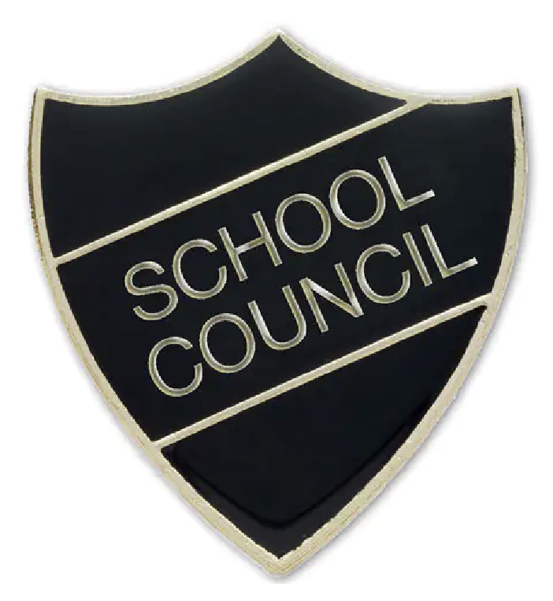

School Council Application Form

Do you want to be part of our School Council?

Roles & responsibilities
- Represent your class by sharing their ideas, suggestions, and concerns.
- Listen carefully to classmates so that everyone’s voice is heard.
- Take part in meetings to discuss school decisions and improvements.
- Share feedback from meetings with your class in a clear and fair way.
- Be a role model by showing respect, responsibility, and kindness.
- Work with other young governors to make positive changes in the school.
- Help plan and lead projects that make school life even better.

Please be ready to share why you should be chosen with your class and teacher next week. There is space below to make notes to help you present why you should be a part of the School Council this year. Good luck

Name: Class:

The School Council will be announced in our Celebration assembly on the Thursday 2nd October.

