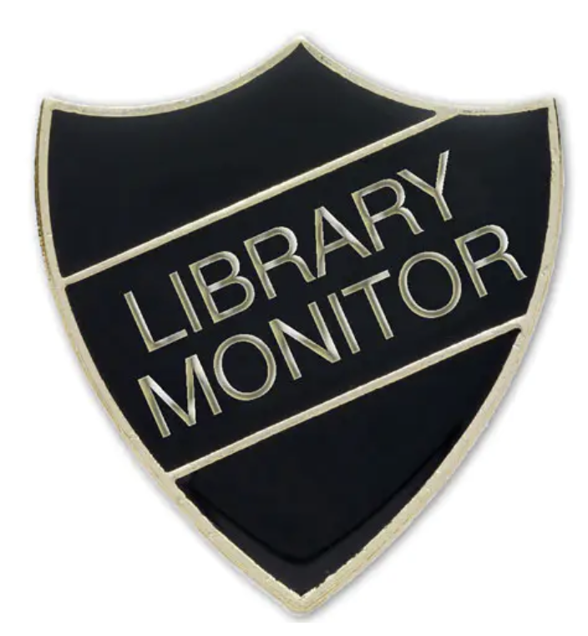

Library Monitor Application Form

Do you want to be a Library Monitor?

Roles & responsibilities
- Look after the library area and keep it tidy and welcoming.
- Help pupils choose books and recommend stories they might enjoy.
- Remind pupils how to treat books with care and respect.
- Support borrowing and returning books, keeping shelves organised.
- Promote different authors and new books to classmates and visitors.
- Create displays or posters to celebrate reading and favourite stories.
- Encourage others to read by sharing personal book recommendations.
- Show a love of reading and set a good example to others.
- Represent the school by helping make the library an enjoyable place for all.

Please be ready to share why you should be chosen with your class and teacher next week. There is space below to make notes to help you present why you should be a Library Monitor this year. Good luck

Name: Class:

The Library Monitors will be announced in our Celebration assembly on the Thursday 2nd October.

