
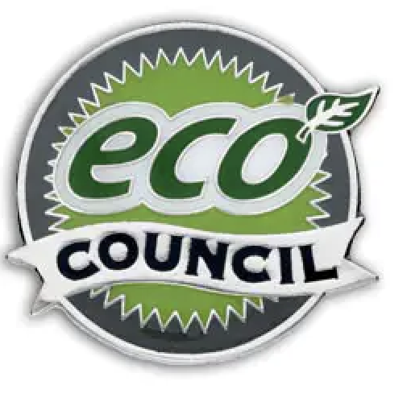
Eco Council Application Form

Do you want to be part of the school’s Eco Council?

Roles & responsibilities
- Help the school make choices that are better for the environment.
- Take part in Eco Council meetings to plan projects and improvements.
- Encourage others to recycle, save energy, and reduce waste.
- Be a role model by showing eco-friendly habits every day.
- Work with staff and pupils to make the school grounds greener and cleaner.
- Support activities like litter picking, recycling drives, or nature projects.
- Share decisions and news from the Eco Council with your class.
- Celebrate successes and encourage everyone to get involved in helping the environment.

Please be ready to share why you should be chosen with your class and teacher next week. There is space below to make notes to help you present why you should be a part of the Eco Council this year. Good luck

Name: Class:

The Eco Council will be announced in our Celebration assembly on the Thursday 2nd October.

