

Bosham Primary School

Calculation Policy

2023

Objective & Strategy | Concrete | Pictorial | Abstract
Combining two parts to make a whole: part- whole model. | Use part whole model.  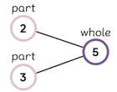  Use cubes to add two numbers together as a group or in a bar.  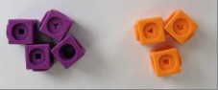 | 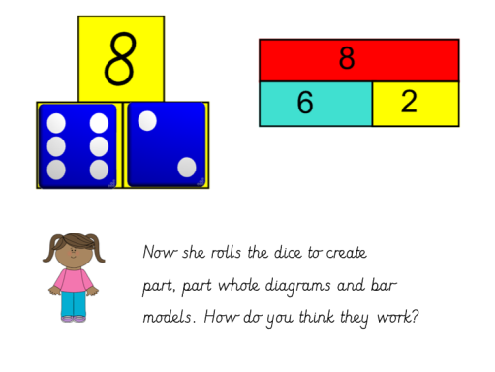  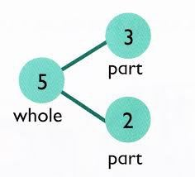  Use pictures to add two numbers together as a group or in a bar. | 4 + 3 = 7  10 = 6 + 4  Use the part- part whole diagram as shown above to move into the abstract.
Starting at the bigger number and counting on. | 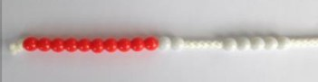  Start at the larger number on the bead string and then count on to the smaller number. | 12 + 5 = 17  Start at the larger number on the number line and count on in ones or in one jump to find the answer. | 5 + 12 = 17  Place the larger number in your head and count on the smaller number to find your answer.
Regrouping to make 10.  This is an essential skill for column addition later. | 6 + 5 = 11  Start with the bigger number and use the smaller number to make 10.  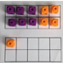  Use 10 frames. | 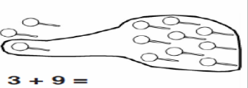  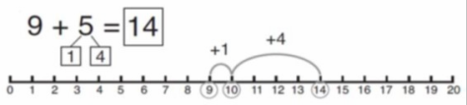  Use pictures of a number line. Regroup or partition the smaller number using the part- part whole model to make 10. | 7 + 4 = 11  If I am at seven, how many more do I need to make 10? How many more do I add on now?
Represent and use number bonds and related subtraction facts within 20. | 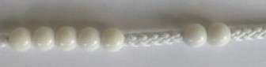  2 more than 5… | 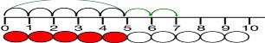  5+ 2 =  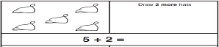 | Emphasis should be on the language.  ‘1 more than 5 is equal to 6’  ‘2 more than 5 is 7’  ‘8 is 3 more than 5’
Addition Year 1

Objective & Strategy | Concrete | Pictorial | Abstract
Adding multiples of ten | 20 + 30 =50  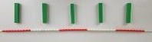  Model using dienes and bead strings. | Use representations for base 10.  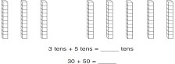 | 20 + 30 = 50  70 = 50 + 20  40 + ___ = 60
Use known number facts  Part part whole | Children explore ways of making numbers within 20.  Use a range of resources. E.g. dienes, bead strings, multilink etc. | Part part whole model.  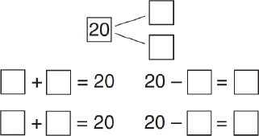 | ____ + 1 = 16  1 + ____ = 16  16 – 1 = ____  16 - _____ = 1
Using known facts | + = | Children draw representations of T and O.  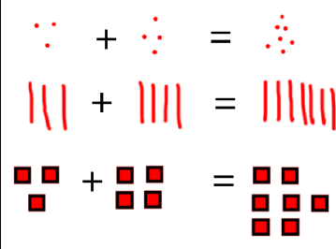 | 3 + 4 = 7  leads to  30 + 40 = 70
Bar model | 3 + 4 = 7  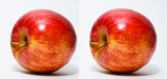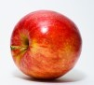 | 7 + 3 = 10  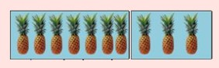 | 7+ 5=  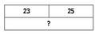

Addition Year 1

Objective & Strategy | Concrete | Pictorial | Abstract
Add a two digit number and ones | 17 + 5 = 22  Use ten frame to make tens.  Children explore the pattern.  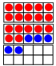  17 + 5 = 22  27 + 5 = 32 | Use part part whole and number line to model.  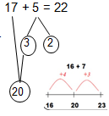 | 17 + 5 = 22  Explore related facts  17 + 5 = 22  5 + 17 = 22  22 – 17 = 5  22- 5 = 17  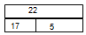
Add a 2 digit number and tens | 25 + 10 = 35  Explore that the ones digit does not change.  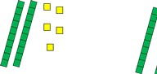 | 27 + 30 =  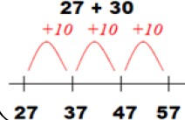 | 27 + 10 = 37  27 + 20 = 47  27 + ____ = 57
Add two 2 digit numbers | Model using dienes, place value counter and numicon.  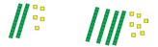 | 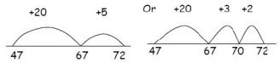  Use number line and bridge ten using part whole if necessary. | 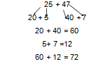
Add three 1 digit numbers | Combine to make 10 first if possible, or bridge 10 then ad third digit.         | Regroup and draw representation.  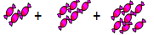  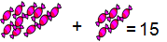 | 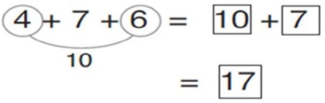  Combine the two numbers that make/bridge ten then add on the third.

Addition Year 2

Objective & Strategy | Concrete | Pictorial | Abstract
Column addition- no regrouping.  Add two or three 2 or 3 digit numbers. | Model using dienes or numicon.  Add together the ones first, then the tens. | Children to move to drawing the counters using tens and one frame.  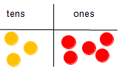 | Add the ones first, then the tens, then the hundreds.  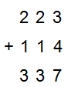
Column addition with regrouping. | Exchange tens ones for a ten.  Model using numicon and counters. | Children can draw a representation of the grid to further support their understanding, carrying the ten underneath the line.  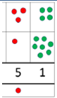 | Start by partitioning the numbers before formal column to show the exchange.  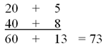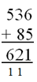
Addition Year 3

Objective & Strategy | Concrete | Pictorial | Abstract
Year 4- Add numbers with up to 4 digit  Addition Year 4- 6 | Children continue to use dienes or counters to add, exchanging ten ones for a ten and ten tens for a hundred and ten hundreds for a thousand.  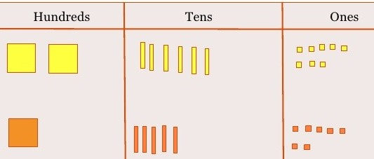 | Draw representations using grids.  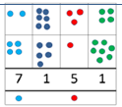 | Continue from previous work to carry hundreds as well as tens.  Relate to money and measures.
Year 5 - add numbers with more than 4 digits.  Add decimals with 2 decimal places, including money. | As year 4. Introduce decimal place value counters and model exchange for addition.  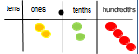 | 2.37 + 81.79 =  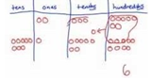 | 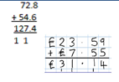
Year 6- Add several numbers of increasing complexity. | As Y5. | As Y5. | Insert zeros for place holders.  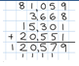

Objective & Strategy | Concrete | Pictorial | Abstract
Taking away ones. | Use physical objects, counters, cubes etc to show how objects can be taken away.  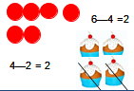 | Cross out drawn objects to show what has been taken away.  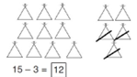 | 7 – 4 = 3  16 – 5 =11
Counting back | Move objects away from the group, counting backwards.  Move the beads along the bead string as you count backwards.  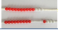 | Count back in ones using a number line.  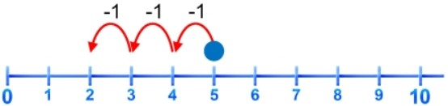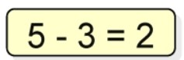 | Put 9 in your head, count back 4. What number are you at?
Find the difference | Compare objects and amounts.  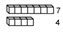  ‘Seven is 3 more than four’  ‘I am 2 years older than my sister’  Lay objects to represent bar model. | Count on using a number line to find the difference.  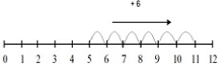 | Hannah has 6 sweets and her sister has 5. How many more does Hannah have than her sister?
Subtraction Year 1

Objective & Strategy | Concrete | Pictorial | Abstract
Represent and use number bonds and related subtraction facts within 20.  Part part whole model | Link to addition. Use part part whole model to model the inverse.  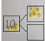  If 10 is the whole and 6 is one of the parts, what is the other part?  10- 6 = 4 | 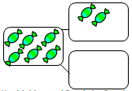  Use pictorial representations to show the part. | Move to using numbers within the part whole model.  5  7  12
Make 10. | 14 – 9 =  Make 14 on the ten frames. Take 4 away to make ten, and then take one more away so that you have taken 5.  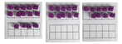 | Jump back 3 first, then another 4.  4. Use ten as the stopping point.  13- 7 =  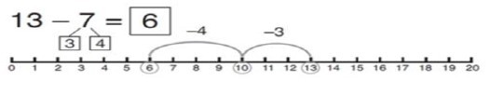 | 16 – 8 =  How many do we take off first to get to 10?  How many left to take off?
Bar model | 5 – 2 = 3  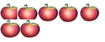 | 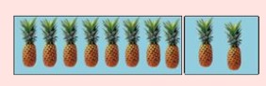 | 10 = 8+ 2  10 = 2 + 8  10-2 = 8  10-8 = 2  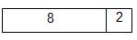
Subtraction Year 1

Subtraction Year 2
Objective & Strategy | Concrete | Pictorial | Abstract
Regroup a ten into ten ones. | Use dienes to show how to change a ten into ten ones.  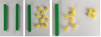 | 12 – 4 = | 20 – 4 = 16  20 - ___ = 16  16 = 20 - 4
Partitioning to subtract without re-grouping. | 34- 13 = 21  Use dienes to show how to partition the number when subtracting without regrouping. | Children to draw representations of dienes and cross off.  43 – 21 = 22 | 43 – 21 = 22  43 - ___ = 22  22 = 43 - 21
Make ten strategies. | Use a bead bar or bead strings to model counting to next ten and the rest.  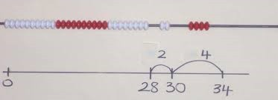 | Use a number line to count onto the next ten and then the rest.  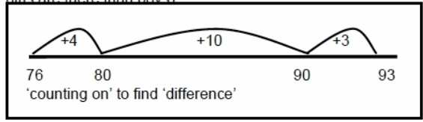 | 93- 76 = 17  93- ____ = 17  93 - 17 =

Objective & Strategy | Concrete | Pictorial | Abstract
Column subtraction without re grouping. | Use base 10 or numicon to model.  47 – 32 =  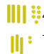 | Draw representations to support understanding.  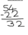 | Intermediate step may be needed to lead to clear subtraction understanding.  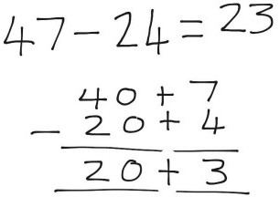
Column subtraction with regrouping. | Begin with numicon. Move to counters, modelling the exchange of a ten into ten ones. | Children may draw base ten or counters and cross off.  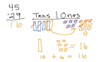 | Begin by partitioning into columns.  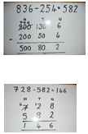  Then move to formal method.

Subtraction Year 3

Objective & Strategy | Concrete | Pictorial | Abstract
Year 4- Subtract with up to 4 digits.  Introduce decimal subtraction through context of money.  Subtracting tens and ones | 234- 179 =  Model process of exchange using numicon, base ten and then counters.  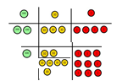 | Children to draw counters and show their exchange- see Year 3. | 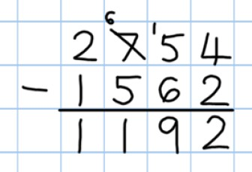  Use the phrase ‘exchange’.
Year 5- Subtract with at least 4 digits, including money and measures.  Subtract with decimal values, including mixtures of integers and decimals and aligning the decimal. | As year 4. | Children to draw counters to show their exchange.- see Year 3. | 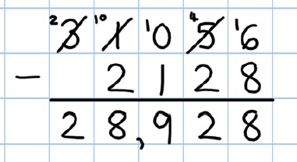  Use zeros for place- holders.
Year 6- Subtract with increasingly large and more complex numbers and decimal values. |  |  | 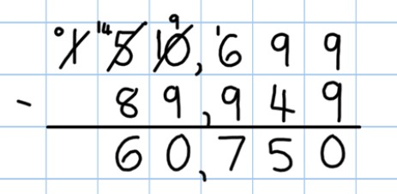  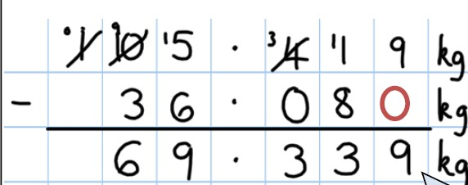
Subtraction Year 4- 6

Objective & Strategy | Concrete | Pictorial | Abstract
Doubling | Use practical activities using manipulatives including cubes, numicon to demonstrate doubling.  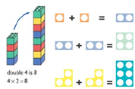 | Draw pictures to show how to double numbers.  Double 4 is 8.  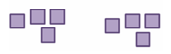 | Partition a number and then double each part before recombining it back together.  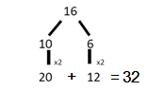
Counting in multiples | Count the groups as children are skip counting, children may use their fingers as they are skip counting.  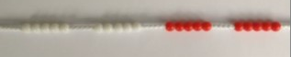  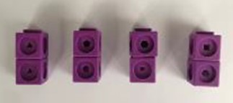 | Children make representations to show counting in multiples.    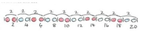 | Count in multiples of a number aloud.  Write sequences with multiples of numbers.  2, 4, 6, 8, 10  5, 10, 15, 20, 25, 30
Making equal groups and counting the total | Use manipulatives to create equal groups.  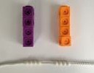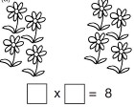 | Draw and make representations. | 2 x 4 = 8  2 x ___ = 8  8 = 2 x 4
Multiplication Year 1

Objective & Strategy | Concrete | Pictorial | Abstract
Repeated addition | Use different objects to add equal groups.  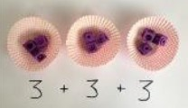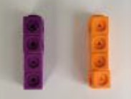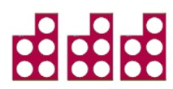 | Use pictorial resources including number lines to solve problems.  There are 3 sweets in one bag.  How many sweets are in 5 bags altogether?  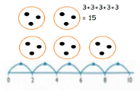 | Write addition sentences to describe objects and pictures.  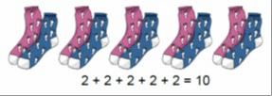
Understanding arrays | Use objects laid out in arrays to find the answers to 2 lots of 5, 3 lots of 2 etc.  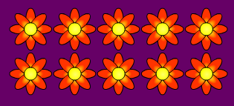 | Draw representations of arrays to show understanding. | 3 x 2 = 6  2 x 5 = 10  3 x 10 =
Multiplication Year 1

Objective & Strategy | Concrete | Pictorial | Abstract
Doubling | Model doubling using dienes and counters.  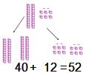 | Draw pictures and representations to show how to double numbers. | Partition a number and then double each part before recombining it back together.  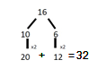
Counting in multiples of 2, 3, 4, 5, 10 from 0.  Multiplication Year 2  (repeated addition) | Count the groups as children are skip counting, children may use their fingers as they are skip counting. Use bar models.  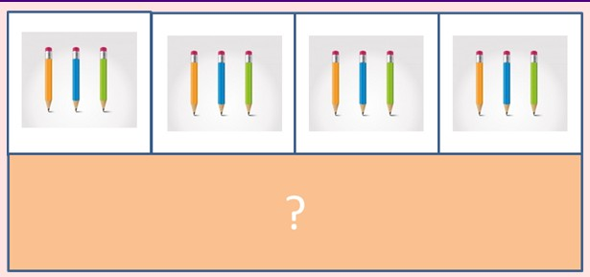 | Number lines, counting sticks and bar models should be used to show representation of counting in multiples.  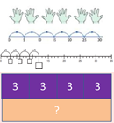 | Count in multiples of a number aloud.  Write sequences with multiples of numbers.  0, 2, 4, 6, 8, 10  0, 3, 6, 9, 12, 15  0, 5, 10, 15, 20, 25, 30  4 x 3 = _____
Multiplication is commutative | Create arrays using counters, cubes and numicon.  Pupils should understand that an array can represent different equations and that, as multiplication is commutative.  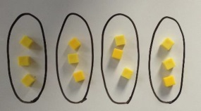  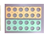 | Use representations of arrays to show different calculations and explore commutativity.  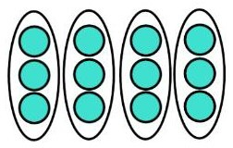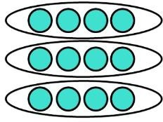 | 12 = 3 x 4  12 = 4 x 3  Use an array to write multiplication sentences and reinforce repeated addition.  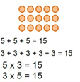
Using the inverse.  This should be taught alongside division, so pupils learn how they work alongside each other. | 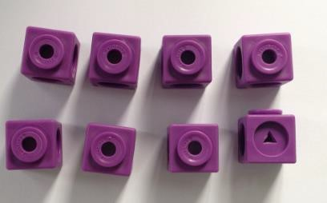 | 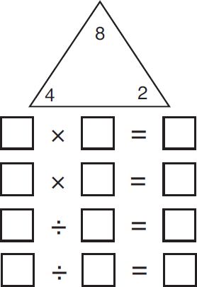 | 2 x 4 = 8  4 x 2 = 8  8 ÷ 2 = 4  8 ÷ 4 = 2  8 = 4 x 2  8 = 2 x 4  2 = 8 ÷ 4
Multiplication Year 2

Multiplication Year 3

Objective & Strategy | Concrete | Pictorial | Abstract
Grid method | Show the links with arrays to first introduce the grid method.  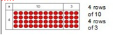  Move onto base ten to move towards a more compact method.  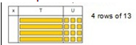 | Children can represent their work with place value counters in a way that they understand.  Bar model are used to explore missing numbers.  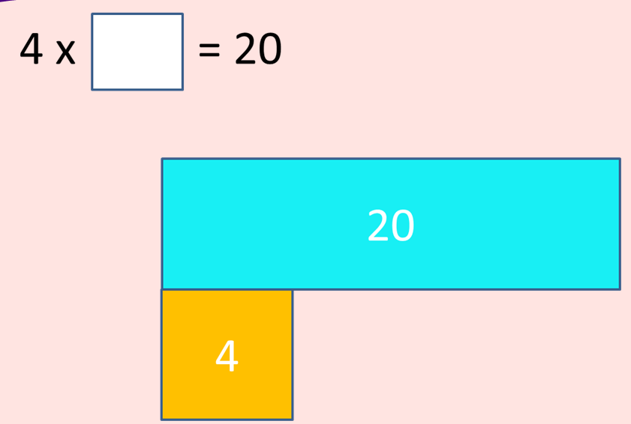 | Start with multiplying by one digit numbers and showing the clear addition alongside the grid.  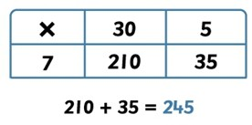  Moving forward, multiply by a 2 digit number showing the different rows within the grid method.  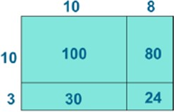

Objective & Strategy | Concrete | Pictorial | Abstract
Grid method recap from Year 3 for 2 digit x 1 digit. | Use place value counters to show how we are finding groups of a number. We are multiplying by 4 so we need 4 rows.  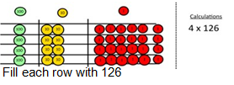 | Children can represent their work with place value counters in a way that they understand. | Start with multiplying by one digit numbers and showing the clear addition alongside the grid.
Column multiplication  Up to 3 digits. | Children can continue to be supported by place value counters at the stage of multiplication. This is initially done where there is no regrouping. They must multiply by the ones first.  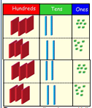 | The grid method may be used to show how this relates to a formal written method.  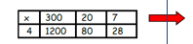 | 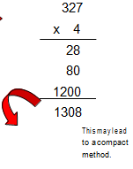  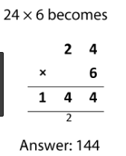
Multiplication Year 4

Objective & Strategy | Concrete | Pictorial | Abstract
Column multiplication for 3 and 4 digit x 1 digit. | Children can continue to be supported by place value counter at the stage of multiplcation. This is initally done where there is no regrouping. 321 x 2 = 642  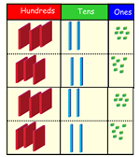 | 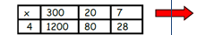 | 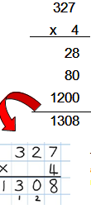
Column multiplication | Maniputlatives may still be used with the coresponding long multiplation modelled alongside. | 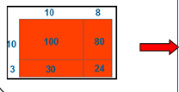  Continue to use the bar modellignt o support problem solving. | 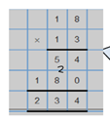
Multiplication Year 5-6

Multiplication Year 6
Objective & Strategy | Concrete | Pictorial | Abstract
Multiplying decimals up to 2 decimal places by a single digit. |  |  | Remind children that the single digit belongs in the ones column. Line up the decimal points in the question and the answer.  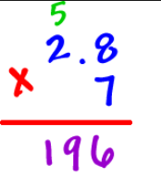  

Objective & Strategy | Concrete | Pictorial | Abstract
Division as sharing | 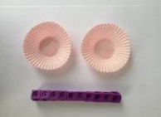  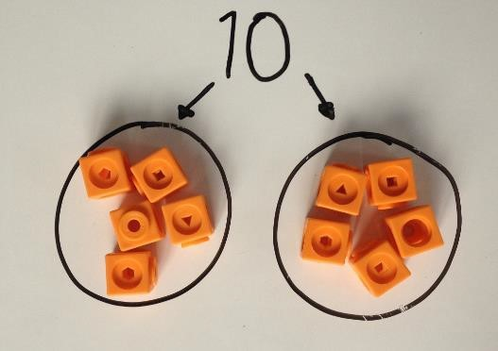  I have 10 cubes, can you share them equally in 2 groups. | Children use pictures or shapes to share quantities.  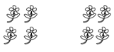  8 shared between 2 is 4.  Sharing:  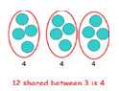 | 12 shared between 3 is 4.  Division Year 1
Objective & Strategy | Concrete | Pictorial | Abstract
Division as sharing  Division Year 2 | 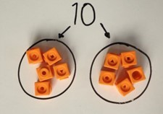  I have 10 cubes, can you share them equally in 2 groups? | Children use pictures or shapes to share quantities.  Children use bar modelling o show and support understanding.  12 ÷ 4 =  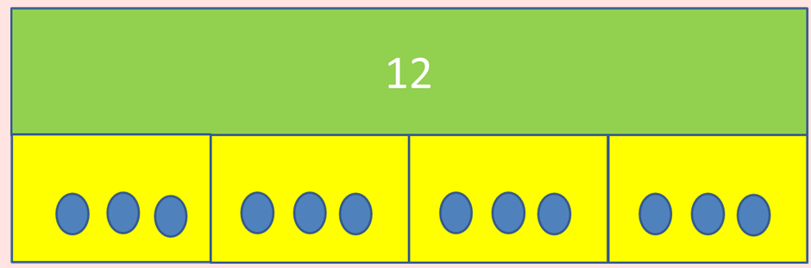 | 12 ÷ 3 =
Division as grouping | Divide quantities into equal groups. Use cubes, counters, objects or place value counters to aid understanding. 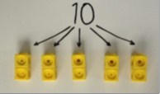 | Use number lines for grouping  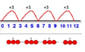  Use bar modelling to support.  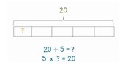 | 28 ÷ 7 = 4  Divide 28 into 7 groups. How many are in each group?

Division Year 3

Objective & Strategy | Concrete | Pictorial | Abstract
Division as grouping | Use cubes, counters, objects or place value counters to aid understanding. | Continue to use bar modelling to aid solving division problems.  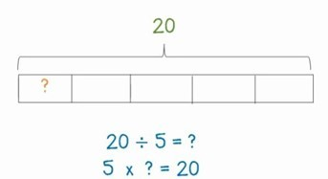 | How many groups of 6 in 24?  24 ÷ 6 = 4
Division with arrays | Link division to multiplication by creating an array and thinking about the number sentences that can be created.  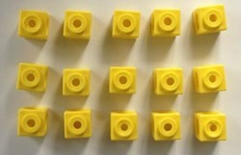 | Draw an array and use lines to split the array into groups to make multiplication and division sentences.  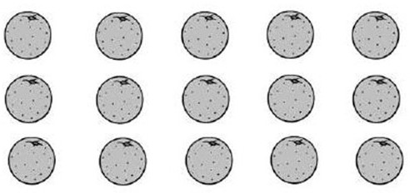 | Find the inverse of multiplication and division sentences by creating eight linking number sentences.  7 x 4 = 28  4 x 7 = 28  28 ÷ 7 = 4  28 ÷ 4 = 7  28 = 7 x 4  28 = 4 x 7  4 = 28 ÷ 7  4 = 28 ÷ 4

Objective & Strategy | Concrete | Pictorial | Abstract
Division with remainders | 14 ÷ 3 =  Divide objects between groups and see how much is left over.  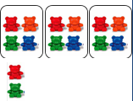 | Jump forwards in equal jumps on a number line and then see how many more you need to jump to find a remainder.  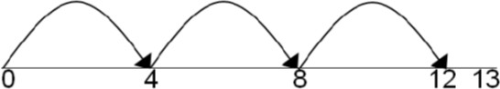  Draw dots and group them to divide an amount and clearly show a remainder.  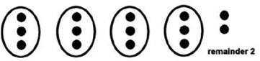  Use bar models to show division with remainders.  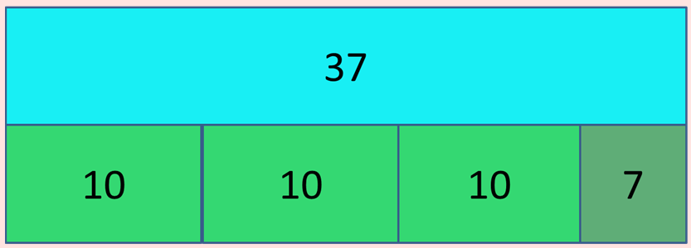 | Complete written divsions and show the remainders using r.  Division Year 3
Objective & Strategy | Concrete | Pictorial | Abstract
Divide at least 3 digit numbers by 1 digit. | 96 ÷ 3 =  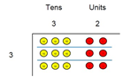  Use place value counters to divide using the bus stop method alongside.  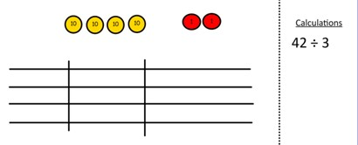 | Students can continue to draw diagrams with dots or circles to help them divide numbers into equal groups.  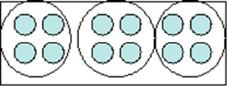  Encourage them to move towards counting in multiples to divide more efficiently. | Begin with divisions that divide equally with no remainder.  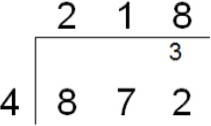  Move into divisions with a remainder.  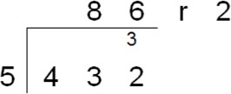  Finally move into decimal places to divide the total accuracy.  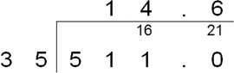  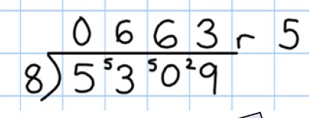

Division Year 4- 6

Long Division
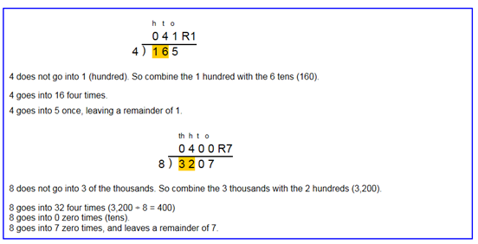

Division Year 6

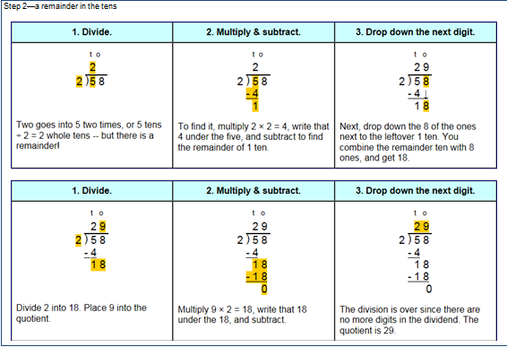
Division Year 6
Division Year 6

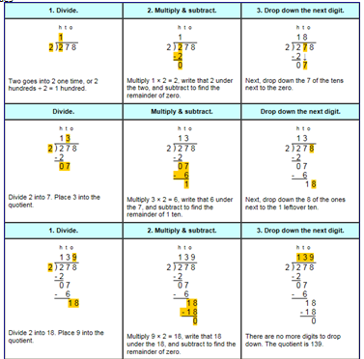

Division Year 6

